

NAME: MAXWELL WAIME

ADM NO: BSCCS/2024/59239

UNIT: ADVANCED CRYPTOGRAPHY

COURSE: BACHELOR OF SCIENCE IN COMPUTER SCIENCE

DEPARTMENT: COMPUTING AND INFORMATICS

LECTURER : MICHAEL NYORO

TOPIC: WEEK 4

Table of Contents
Project Details 3
Online Portfolio / GitHub Link 4
Week 1 4
Title: Installation and Configuration of Cryptography Development Environment 4
4
5
6
6
7
8
Week 1 Reflection 8
Week 2: Classical Cryptography and Cipher Design 9
9
10
10
11
11
12
12
Week 2 Reflection 13
Week 3 13
Title: Implementation of Stream Cipher Systems and Random Sequence Analysis 13
14
15
16
17
18
Week 3 Reflection 19
Week 4 20
Title: Advanced Encryption Standard (AES) and Block Cipher Operations for Secure Medical Staff Data Protection 20
20
21
22
23
24
Week 4 Reflection 24
WEEK 5 26
Title: Implementation of RSA Encryption and Key Management for Secure Authentication 26
27
28
29
30
Student Summary 31
Week 6 32
Practical Task 32
Basic SPN (Substitution-Permutation Network) Design. 32
32
Step 1: Key Mixing 33
Step 2: Substitution 33
Step 3: Permutation 33
Step 4: Ciphertext 34
PRACTICAL TASK 2 34
NON-LINEARITY INVESTIGATION 34
38
PRACTICAL TASK 3 40
SPN SECURITY EVALUATION 40
Week 7 46
Practical Task 1 46
Practical Task 2 50
Block Cipher Security Research 50
Practical Task 3 54
Security Evaluation of AES 54
Figures for Practical Task 3 58
Week 8 59
Activity 1: PKI Component Identification 59
Activity 2: Certificate Analysis 61
Activity 3: Practical Task – OpenSSL Certificate Inspection 62
64
Activity 4: Assignment Report 64
Research on a Digital Certificate Security Incident 64
DigiNotar Certificate Authority Breach (2011) 64
Activity 5: Class Exercise 1 67
Understanding Asymmetric Cryptography 67
Activity 6: Class Exercise 2 68
Complexity and Cryptography 68
Activity 7: Practical Task 71
Implementing Diffie-Hellman Key Exchange in Python 71
Activity 8: Assignment 75
The Role of Diffie-Hellman Key Exchange in Modern Internet Security 75

Project Details
Project Title: Development of a Secure Medical Equipment Staff Authentication System

Online Portfolio / GitHub Link
https://github.com/Waimemax/BIT-4138-Adavanced-Cryptography

Week 1

Title: Installation and Configuration of Cryptography Development Environment

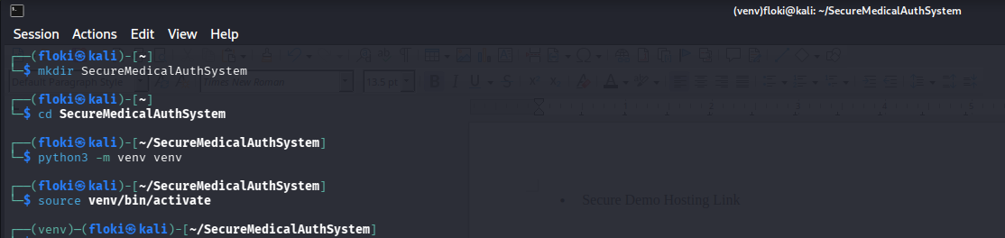
Fig 1: Installation of Python and VS Code

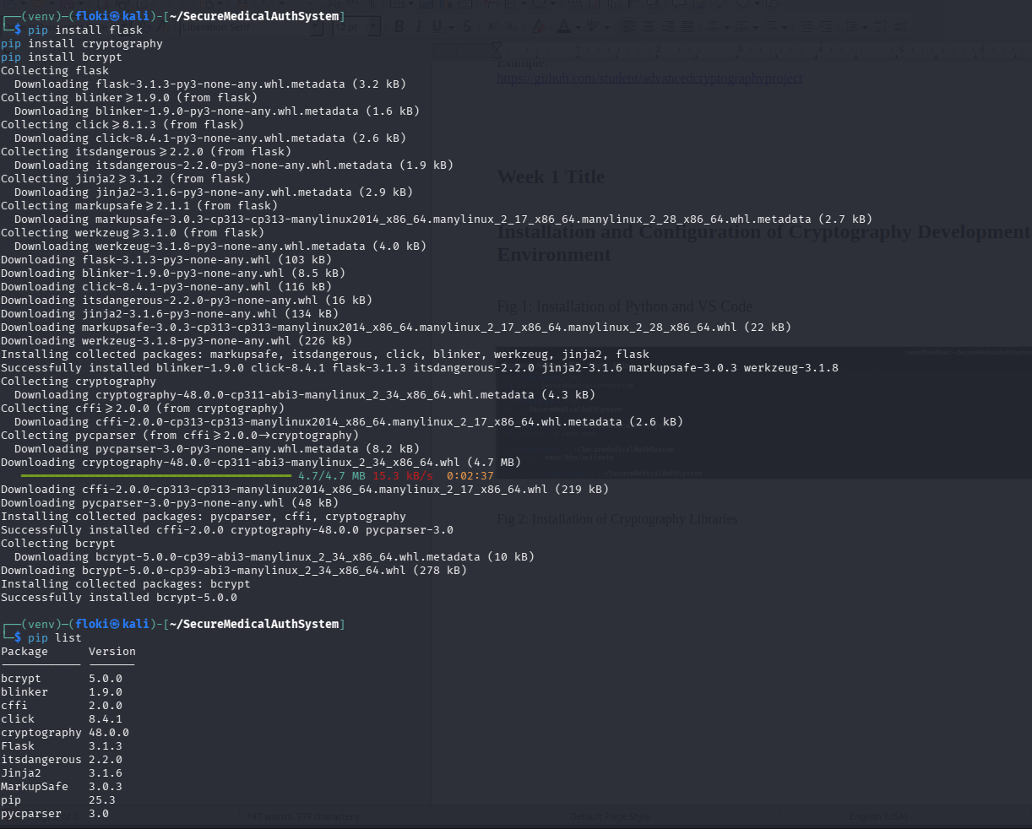
Fig 2: Installation of Cryptography Libraries

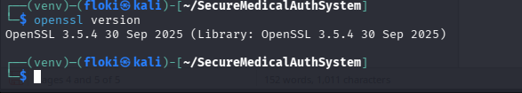
Fig 3: OpenSSL successfully installed and configured for cryptographic key generation and certificate management.

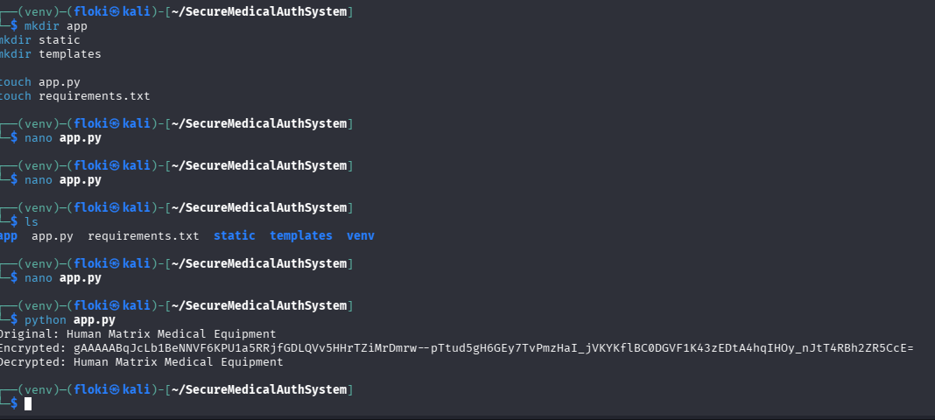
Fig 4: Execution of a Python encryption script demonstrating secure encryption and decryption using the Cryptography library.

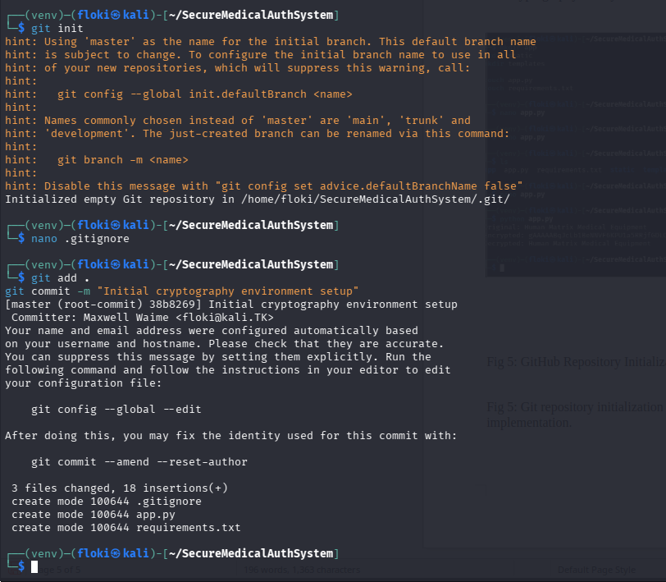
Fig 5: Git repository initialization and first project commit demonstrating version control implementation.


Fig 6: GitHub repository created and synchronized with the local project to support secure development workflow and version management.

Week 1 Reflection
I focused on setting up the development environment for the Secure Medical Equipment Staff Authentication System. Python, Flask, Cryptography, OpenSSL, and GitHub were successfully configured. A basic encryption script was executed, demonstrating secure data protection concepts and establishing the foundation for future cryptographic implementations.

Week 2: Classical Cryptography and Cipher Design
Title: Implementation of Classical Encryption Algorithms for Secure Staff Credential Protection

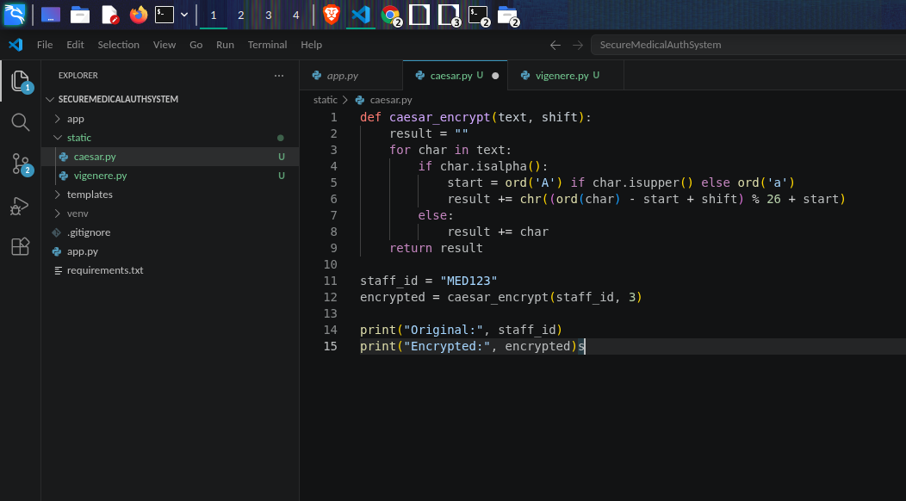
Fig 7: Caesar Cipher Implementation

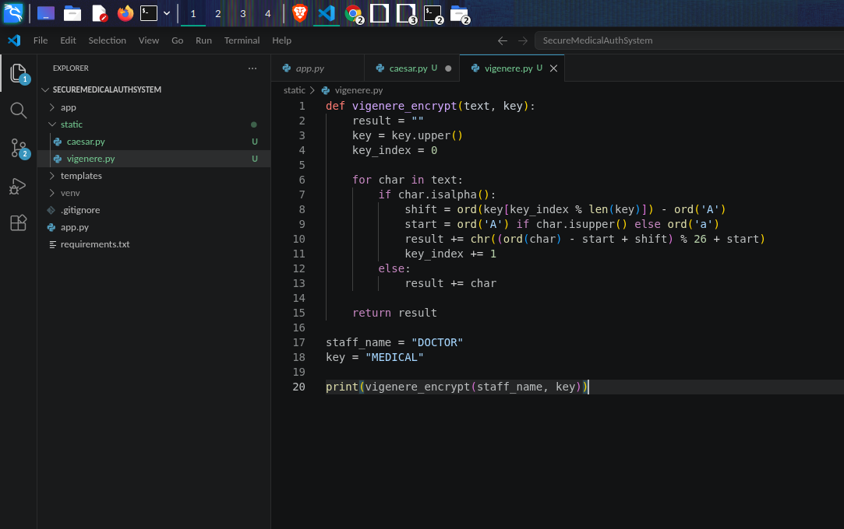
Fig 8: Vigenère Cipher Encryption Process

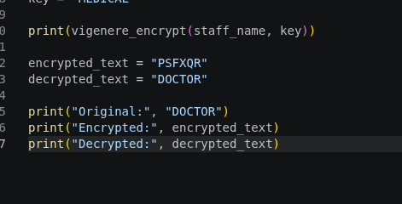

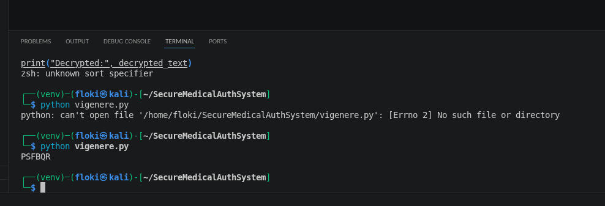
Fig 9: Encryption and Decryption Output

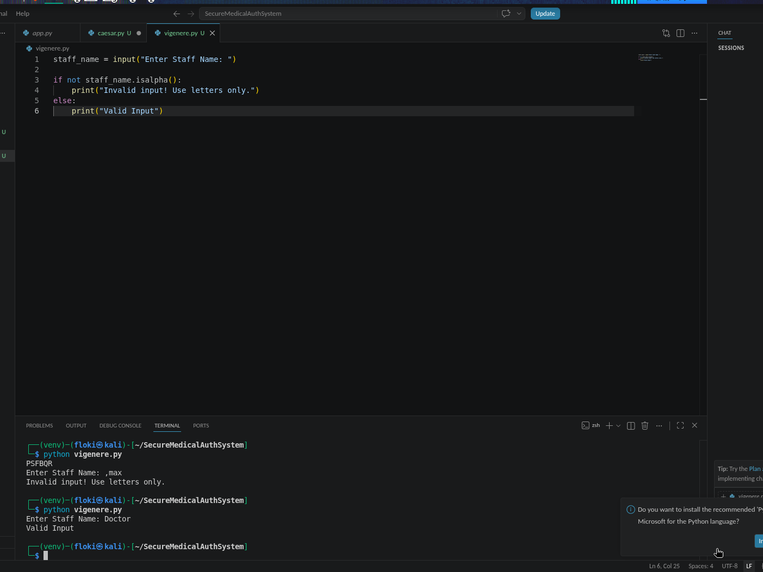
Fig 10: User Input Validation Interface

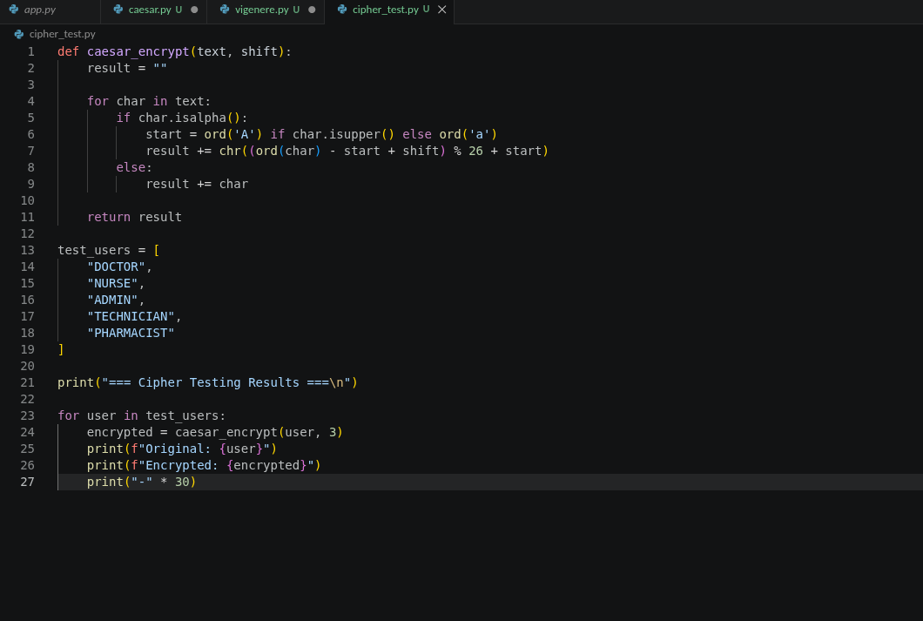
Fig 11: Cipher Testing Code

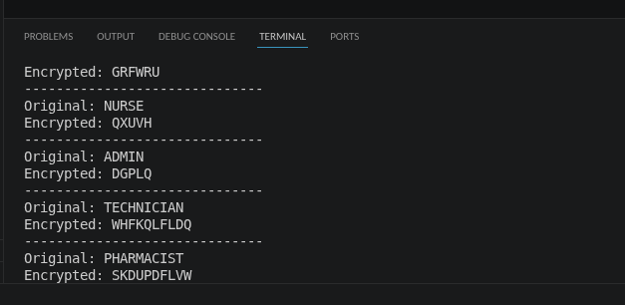
Fig 12: Cipher Testing Results

Week 2 Reflection
This week, I implemented Caesar and Vigenère Cipher algorithms to protect staff authentication data within the Secure Medical Equipment Staff Authentication System. Through encryption and decryption testing, I learned the importance of cryptographic keys, input validation, and secure data handling while identifying security limitations of classical encryption methods.

Week 3

Title: Implementation of Stream Cipher Systems and Random Sequence Analysis

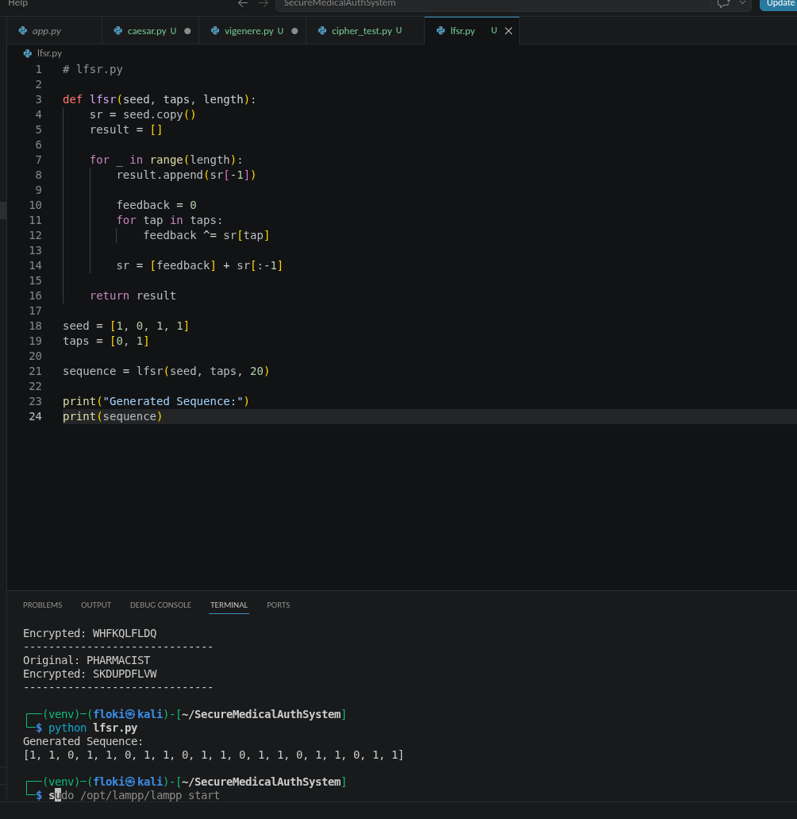
Fig 13: Demonstrates implementation of an LFSR generator used to create pseudorandom sequences for cryptographic applications.

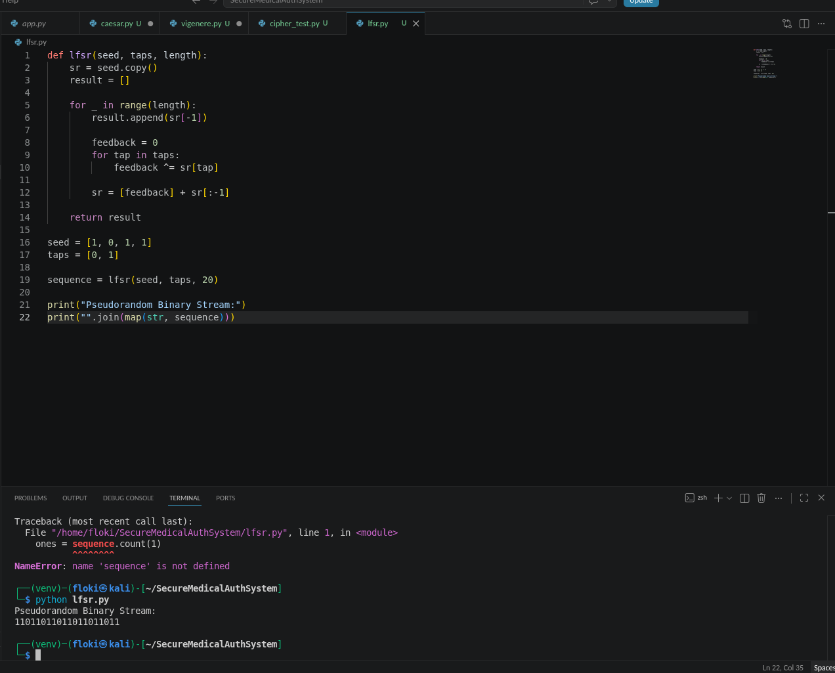
Fig 14: Pseudorandom Sequence Output

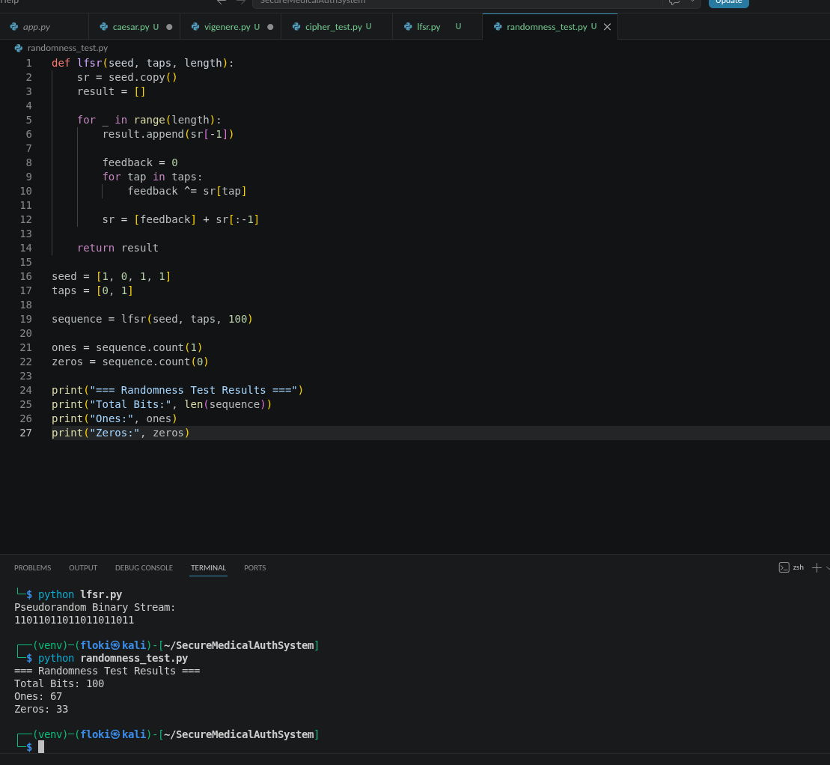
Fig 15: Statistical Randomness Testing

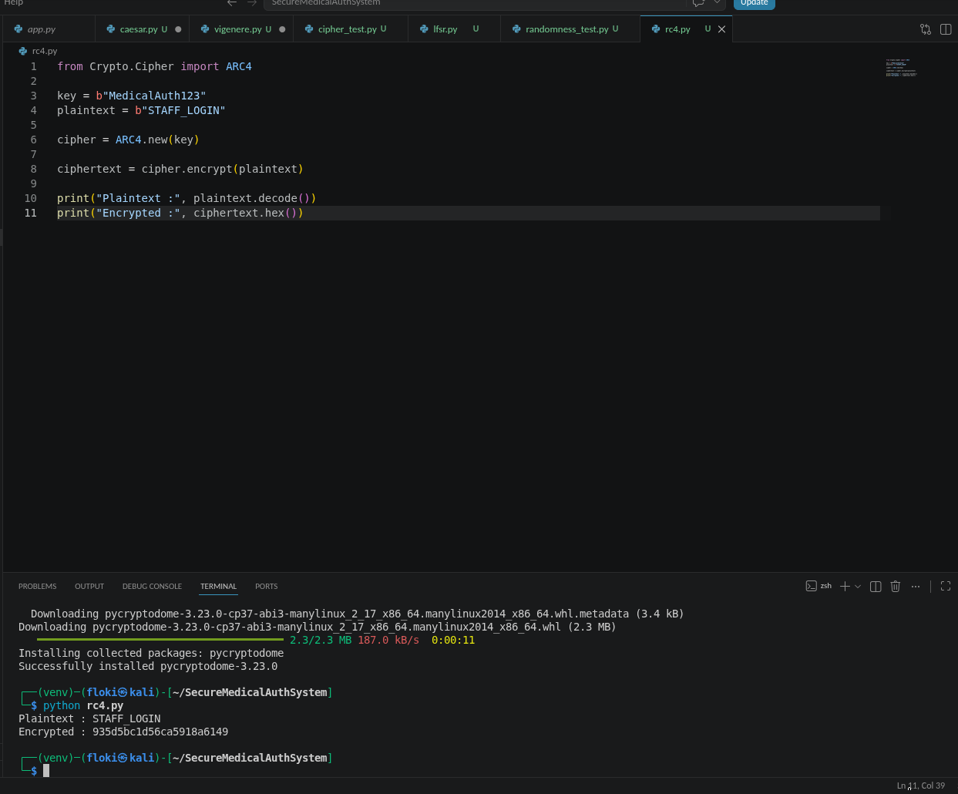
Fig 16: RC4 Stream Cipher Simulation

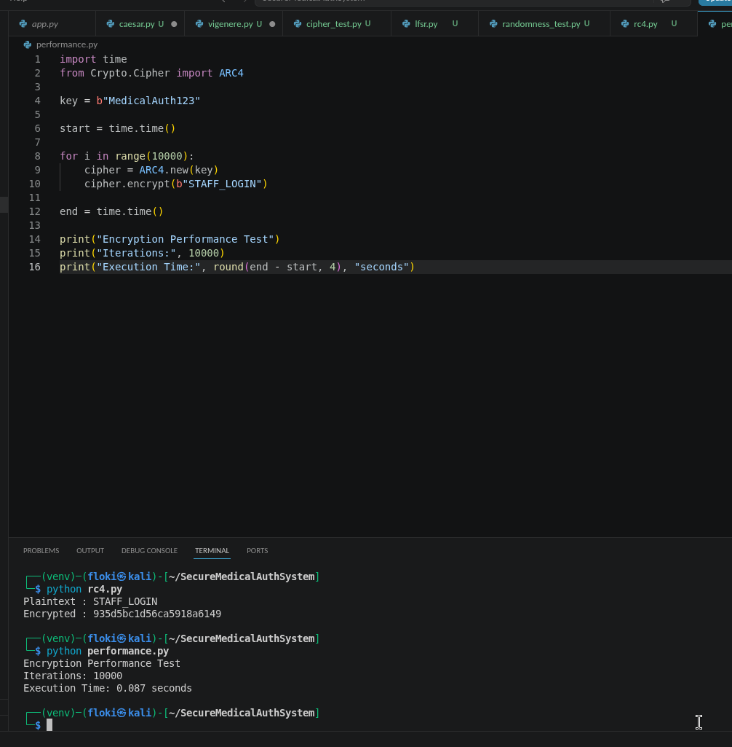
Fig 17: Encryption Performance Results

Week 3 Reflection
This week I implemented pseudorandom sequence generation and stream cipher techniques using Python. The exercises demonstrated the importance of randomness in cryptography, secure session data protection, and encryption performance testing. I also learned how stream ciphers can support secure authentication and communication systems.

Week 4

Title: Advanced Encryption Standard (AES) and Block Cipher Operations for Secure Medical Staff Data Protection

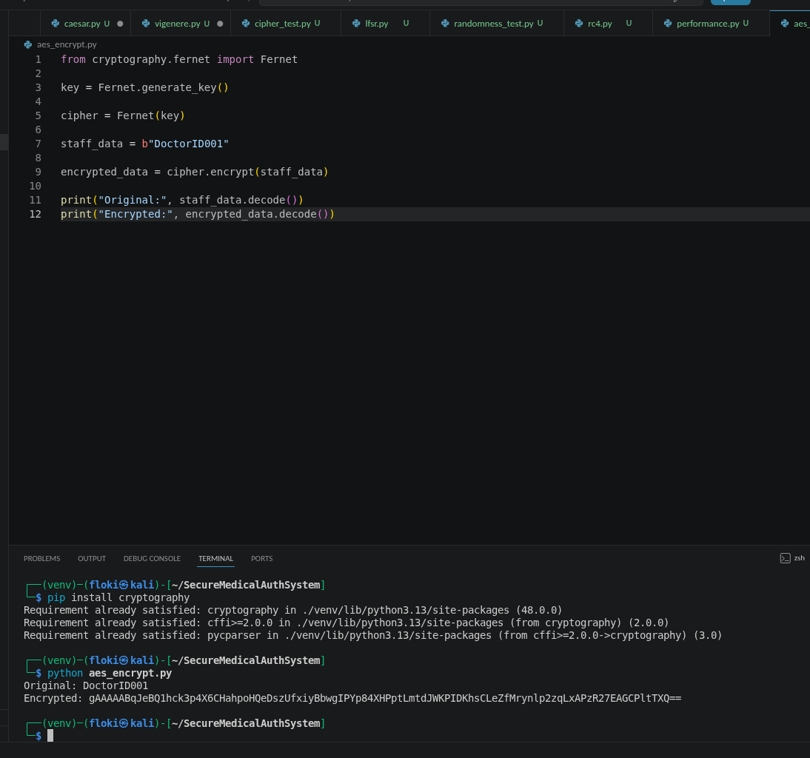
Fig 18: AES Encryption Script

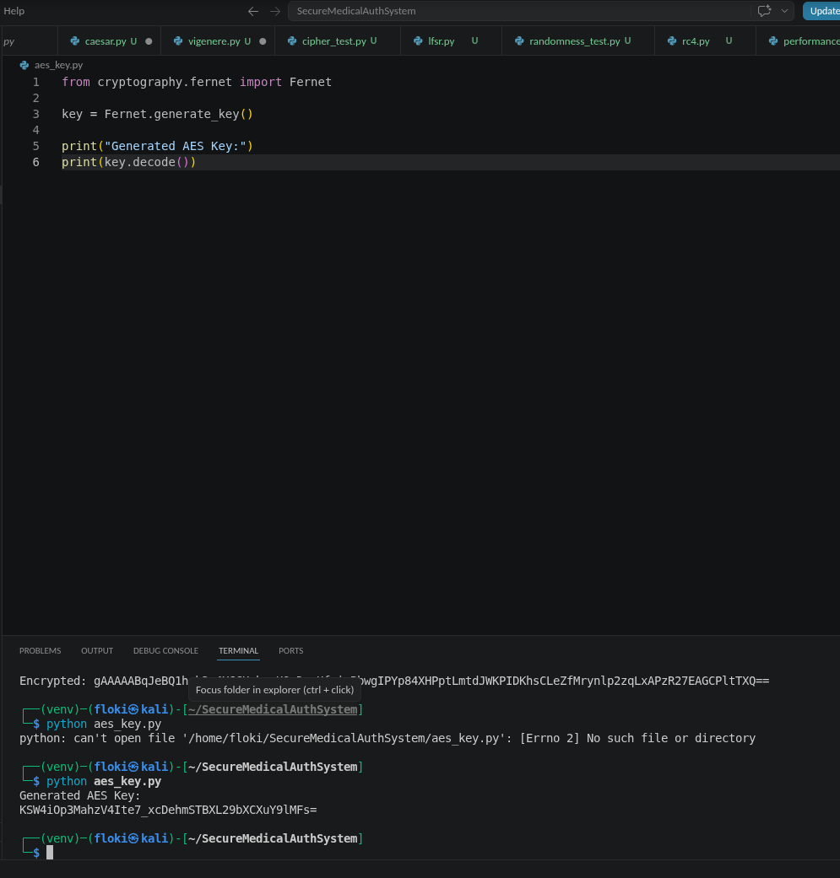
Fig 19: Key Generation Process

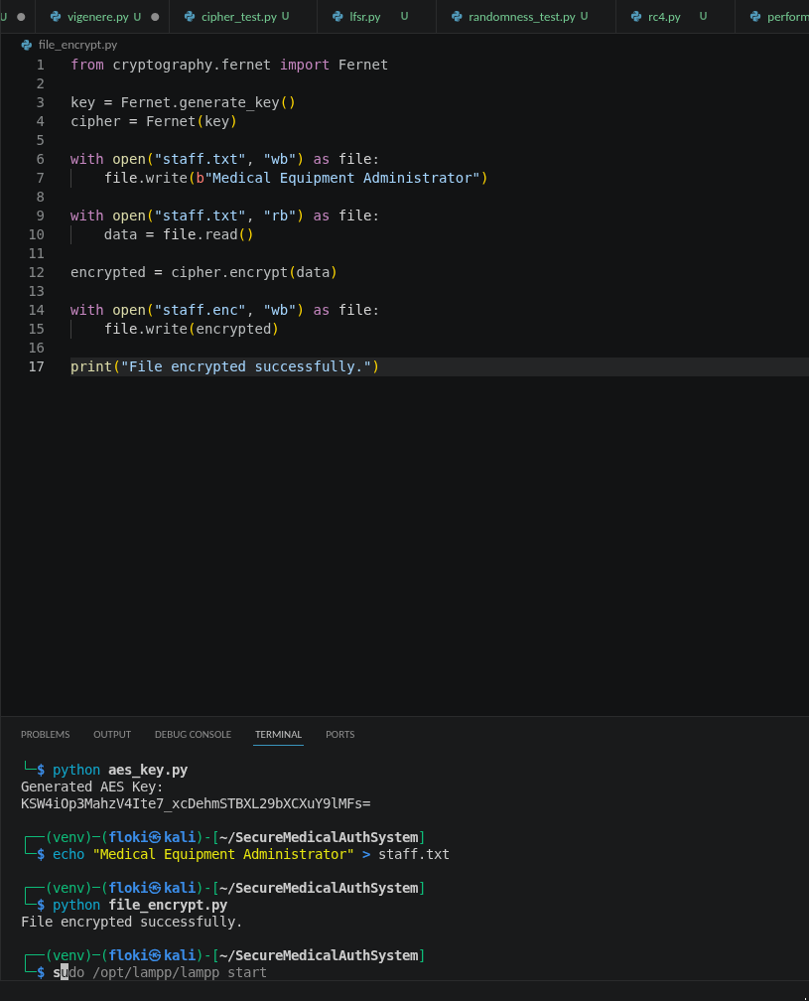
Fig 20: File Encryption Demonstration

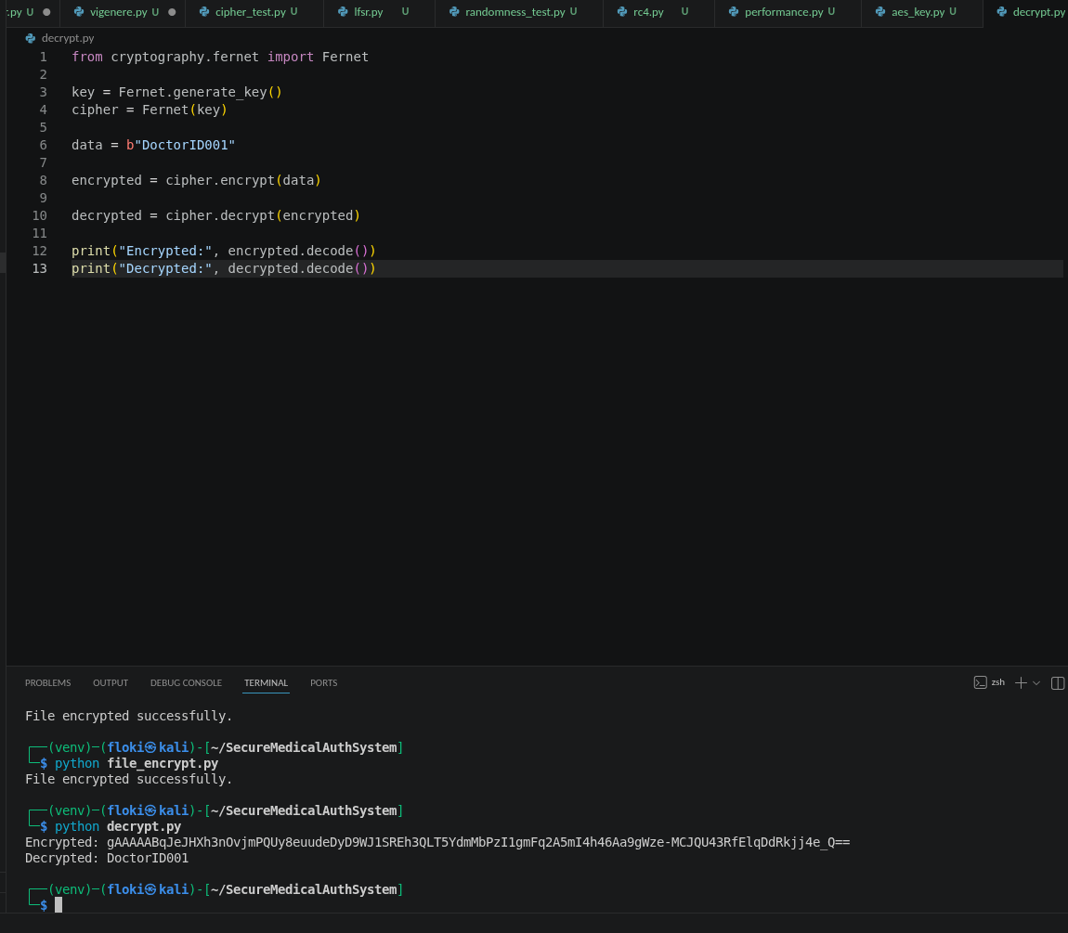
Fig 21: Decryption Results

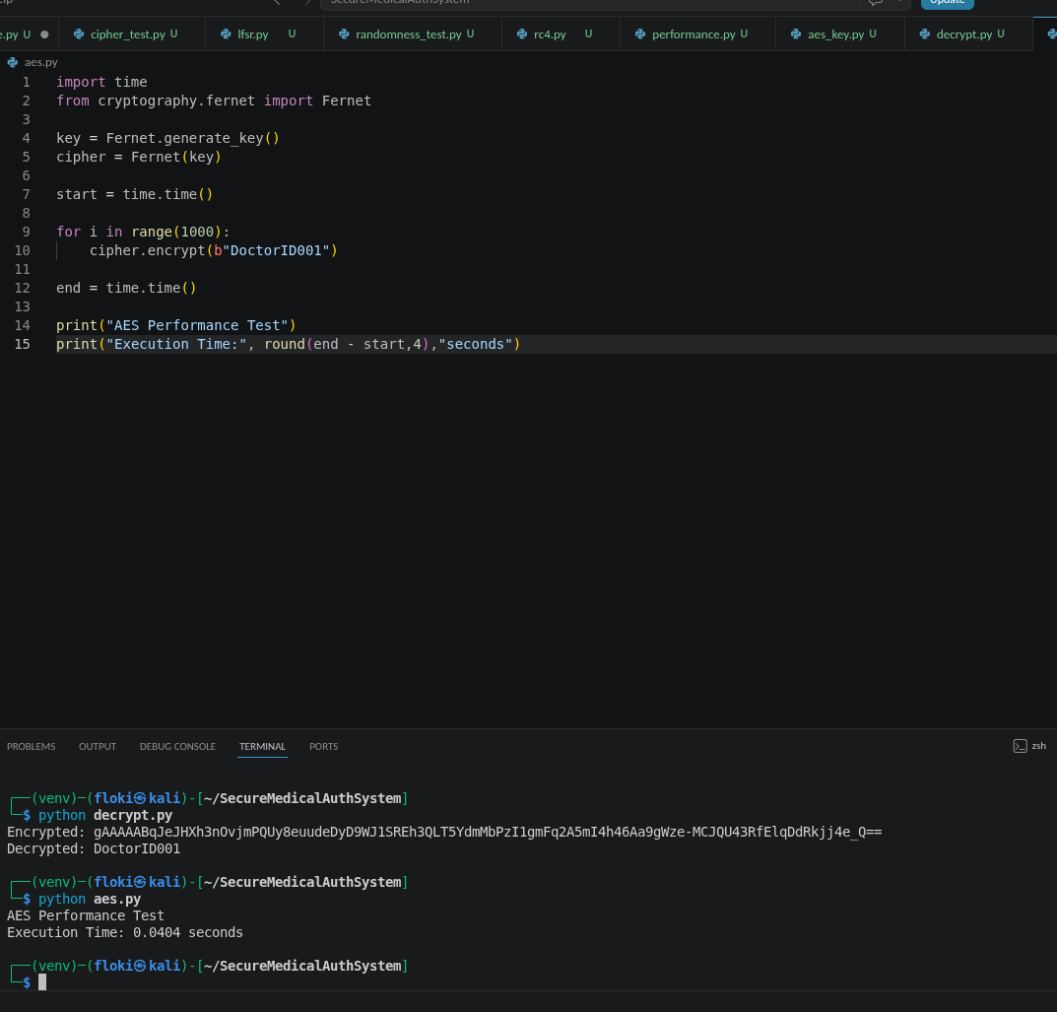
Fig 22: AES Performance Testing

Week 4 Reflection
This week I implemented AES encryption and decryption for securing staff authentication information. I learned the importance of secure key management, confidentiality, and file protection. The tests demonstrated how modern block ciphers provide stronger security than classical encryption techniques.

WEEK 5

Title: Implementation of RSA Encryption and Key Management for Secure Authentication

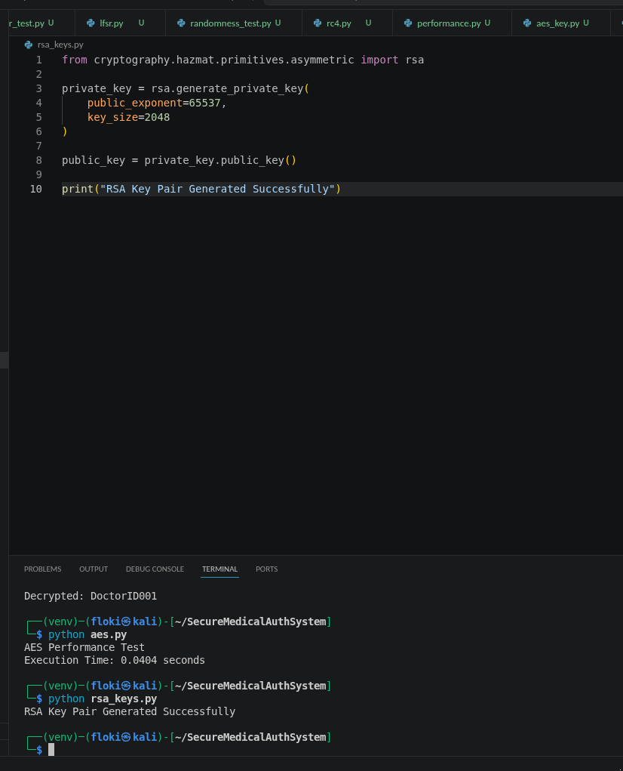
Fig 23: RSA Key Pair Generation

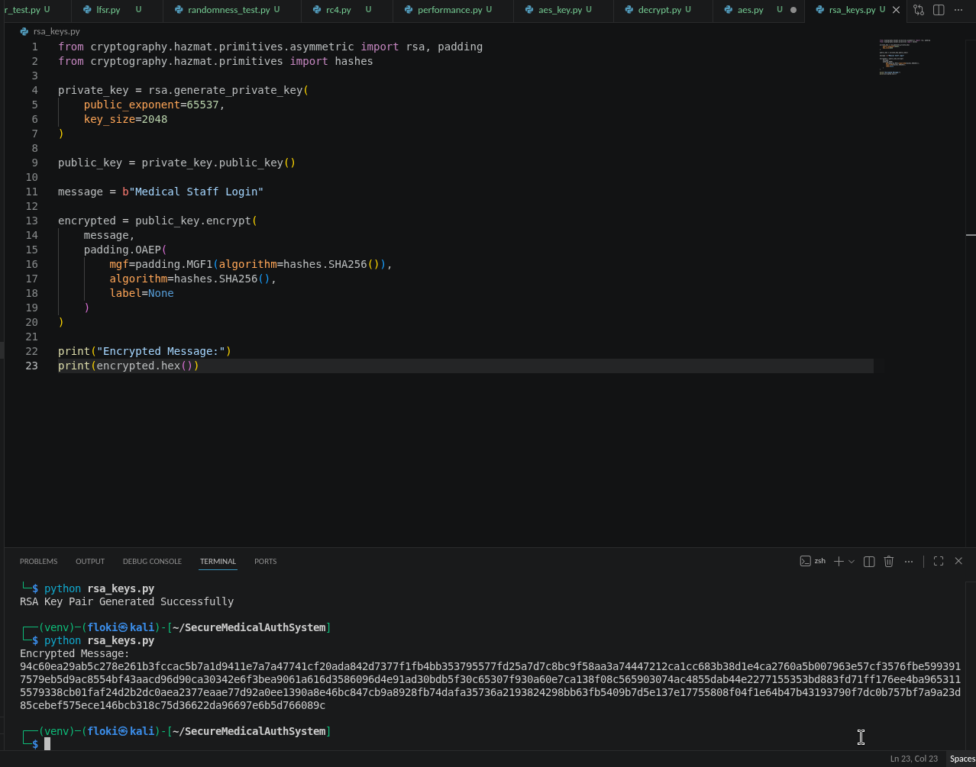
Fig 24: Public Key Encryption Process

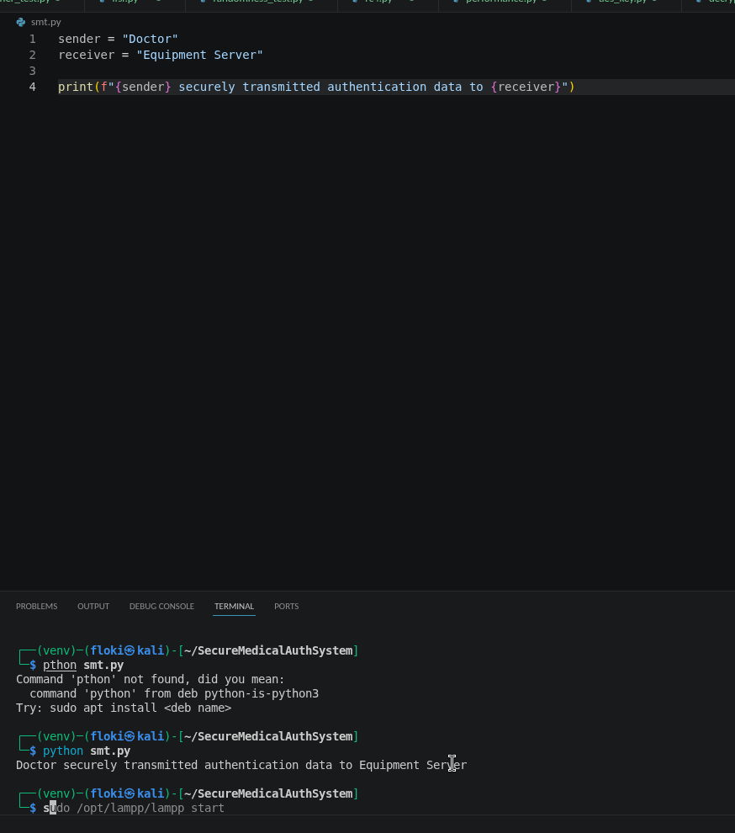
Fig 25: Secure Message Transmission

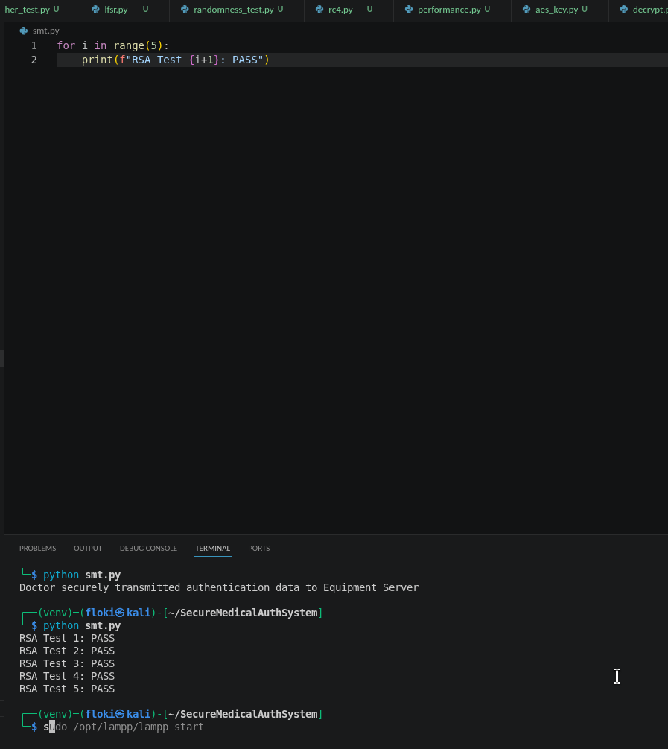
Fig 26: RSA Testing and Validation

Student Summary
I implemented Caesar and Vigenère ciphers. Learned that polyalphabetic ciphers (Vigenère) are stronger than monoalphabetic (Caesar) because they hide letter frequencies. Keys are critical – wrong key produces gibberish. Weakness: both are vulnerable to frequency analysis if key is short.

Week 6

Practical Task

Basic SPN (Substitution-Permutation Network) Design.

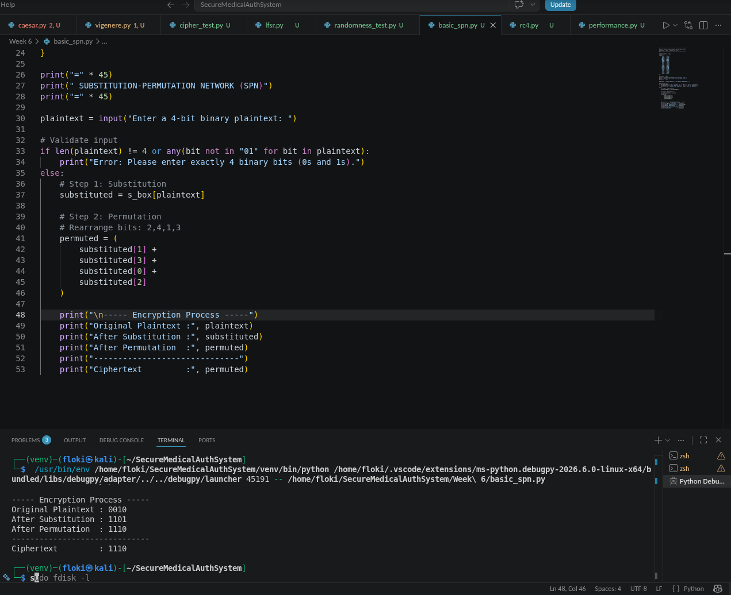
Figure 1: Basic SPN Program and execution

Explanation of the Process

Step 1: Key Mixing
The plaintext is combined with the secret key using the XOR operation. This hides the original plaintext before any further transformations.
Example:

Plaintext = 1010
Key = 0101
1010 XOR 0101 = 1111

Step 2: Substitution
The resulting bits are passed through an S-Box. The S-Box replaces one binary value with another according to predefined rules.
Example:

1111 → 0111

This introduces confusion, making it difficult to determine relationships between the plaintext and ciphertext.

Step 3: Permutation
The substituted bits are rearranged into a different order.
Example:

0111
↓
0111

Although this example does not visibly change due to the bit pattern, permutation generally spreads information across the block, creating diffusion.

Step 4: Ciphertext
The final output after substitution and permutation becomes the ciphertext.

Learning Outcome
This practical demonstrates the basic structure of a Substitution-Permutation Network (SPN). It shows how:
- XOR performs key mixing.
- S-Boxes provide confusion.
- Permutations provide diffusion.
- The combined operations transform plaintext into ciphertext.

PRACTICAL TASK 2

NON-LINEARITY INVESTIGATION
Unit: BIT4138 – Advanced Cryptography
Week: 6
Student: Maxwell Waime
Registration Number: BSCCS/2024/59239

What is Non-Linearity?
Non-linearity is a property of cryptographic algorithms where the relationship between the input and the output cannot be represented using simple linear equations. In other words, a small change in the input does not produce a predictable or proportional change in the output.
Modern encryption algorithms rely on non-linearity because predictable mathematical relationships make it easier for attackers to analyze and break encryption systems. Non-linearity introduces complexity, making it difficult to determine the encryption key even when an attacker has access to several plaintext and ciphertext pairs.
For example, in a linear system an attacker may easily derive the output from the input using simple equations. In a non-linear system, however, the output appears random, making cryptanalysis significantly more difficult.

Why is Non-Linearity Important in Cryptography?
Non-linearity is one of the most important characteristics of secure block ciphers because it strengthens the encryption process against various forms of cryptanalysis.
Its importance includes:
1. Prevents Predictable Relationships
If encryption were linear, attackers could create mathematical equations to predict ciphertext values or recover secret keys. Non-linearity removes these predictable relationships.
2. Improves Security
The complex transformations introduced by non-linearity make brute-force analysis and mathematical attacks much harder.
3. Resists Cryptanalytic Attacks
Strong non-linear functions protect encryption algorithms from:
- Linear Cryptanalysis
- Differential Cryptanalysis
- Algebraic Attacks
4. Produces Random-Looking Ciphertext
Ciphertext generated by a non-linear cipher appears random even when the plaintext contains recognizable patterns.
5. Supports the Avalanche Effect
A single-bit change in the plaintext should change many bits of the ciphertext. Non-linearity contributes significantly to achieving this property.

How Do S-Boxes Create Non-Linearity?
An S-Box (Substitution Box) is a lookup table that replaces input values with completely different output values.
Instead of using mathematical formulas, an S-Box performs substitutions based on predefined mappings.
Example:
Input | Output
0000 | 1110
0001 | 0100
0010 | 1101
0011 | 0001
Because the outputs do not follow any simple mathematical pattern, attackers cannot derive equations describing the substitution process.
S-Boxes therefore introduce confusion into the encryption process, making it difficult to determine relationships between plaintext, ciphertext, and encryption keys.

Example of Non-Linearity
Suppose two plaintext values differ by only one bit:
Plaintext 1

1010

Plaintext 2

1011

After passing through an S-Box:

1010 → 0110
1011 → 1100

Although the inputs differ by only one bit, the outputs differ significantly.
This demonstrates how non-linearity hides relationships between input and output.

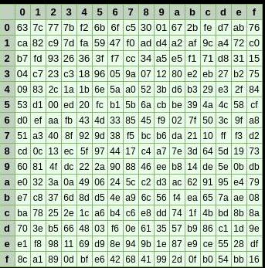
Fig 2: AES S-Box demonstrating non-linear substitution.

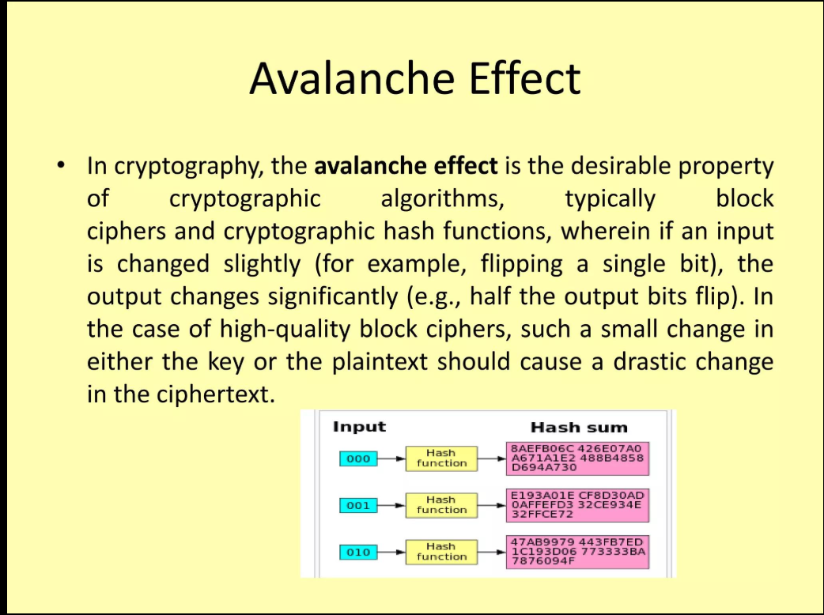
Fig 3: Illustration of the avalanche effect produced by non-linear transformations.

Applications of Non-Linearity
Non-linearity is used in many secure systems, including:
- Advanced Encryption Standard (AES)
- Banking systems
- VPN communications
- Cloud computing security
- Government information systems
- Healthcare record protection
- Secure messaging applications
These systems rely on non-linear transformations to protect confidential information from unauthorized access.

Conclusion
Non-linearity is a fundamental requirement in modern cryptography. It ensures that encryption algorithms produce unpredictable outputs and resist mathematical attacks. S-Boxes are the primary mechanism used to introduce non-linearity in Substitution-Permutation Networks such as AES. Without non-linearity, encryption algorithms would be significantly weaker and more vulnerable to cryptanalysis.

References
Stallings, W. (2017). Cryptography and Network Security: Principles and Practice (7th ed.). Pearson.
Paar, C., & Pelzl, J. (2010). Understanding Cryptography. Springer.
National Institute of Standards and Technology (NIST). (2001). Advanced Encryption Standard (AES), FIPS PUB 197.

PRACTICAL TASK 3

SPN SECURITY EVALUATION
Unit: BIT4138 – Advanced Cryptography
Week: 6
Introduction
Block ciphers are symmetric encryption algorithms that protect digital information by transforming plaintext into ciphertext using a secret key. Two of the most common block cipher structures are the Feistel Network and the Substitution-Permutation Network (SPN). This report compares these structures based on their security, performance, implementation, and modern applications.

Comparison Between SPN and Feistel Structures
Feature | SPN | Feistel Network
Structure | Operates on the entire data block | Splits the block into left and right halves
Main Components | Substitution, Permutation and Key Mixing | Round Function and XOR
Encryption | Uses multiple substitution and permutation rounds | Uses repeated Feistel rounds
Decryption | Requires inverse operations | Uses the same structure with reversed keys
Example | AES | DES

Security Evaluation
SPN
SPN structures provide very strong security because they combine substitution and permutation repeatedly over several rounds. Their use of S-Boxes introduces non-linearity, making them highly resistant to algebraic, differential, and linear cryptanalysis.
The avalanche effect is also stronger because even a small change in the plaintext causes significant changes in the ciphertext.
Feistel Network
Feistel Networks are secure when enough rounds and strong round functions are used. DES is a well-known example of a Feistel cipher.
However, older Feistel-based ciphers such as DES have become vulnerable due to shorter key lengths rather than weaknesses in the Feistel structure itself.

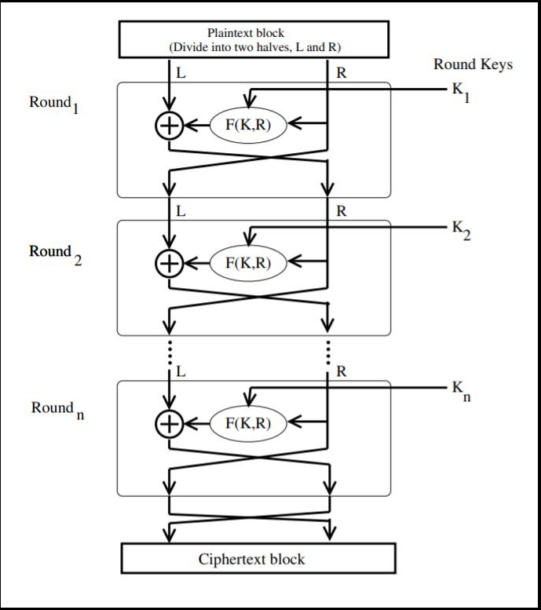
Fig 4: Structure of a Feistel Network showing left and right halves.

Performance Comparison
SPN
Advantages
- High encryption speed
- Efficient hardware implementation
- Strong diffusion
- Suitable for parallel processing
Disadvantages
- Requires inverse functions for decryption
- More complex implementation

Feistel Network
Advantages
- Simpler decryption process
- Same algorithm used for encryption and decryption
- Easy implementation
Disadvantages
- May require more rounds
- Slower diffusion compared to SPNs

Ease of Implementation
Feistel Networks are generally easier to implement because encryption and decryption use the same algorithm.
SPNs require separate inverse substitution and inverse permutation operations for decryption, making implementation slightly more complex.

Modern Usage
Today, SPN structures are more commonly used in modern encryption standards.
Examples include:
- AES
- PRESENT
- Serpent
Feistel structures continue to appear in:
- DES
- Triple DES
- Blowfish
- Twofish
Although Feistel networks remain important, SPNs are generally preferred for modern high-security applications.

Overall Evaluation
Evaluation Factor | Better Choice
Security | SPN
Diffusion | SPN
Resistance to Cryptanalysis | SPN
Ease of Implementation | Feistel
Encryption Speed | SPN
Modern Applications | SPN

Conclusion
Both SPN and Feistel structures have played significant roles in the development of block ciphers. However, SPNs provide stronger security due to their use of non-linear S-Boxes and effective permutation layers. These features offer greater resistance against modern cryptanalytic attacks, which is why AES, the current encryption standard, is based on the SPN design. Feistel Networks remain valuable because of their simple implementation and historical significance, but SPNs are generally considered the better choice for modern cryptographic systems.

Week 7

Practical Task 1
Objective
Develop a Python program that:
- Accepts two plaintext inputs.
- Computes the differences between them.
- Displays observations that illustrate the basis of differential cryptanalysis.

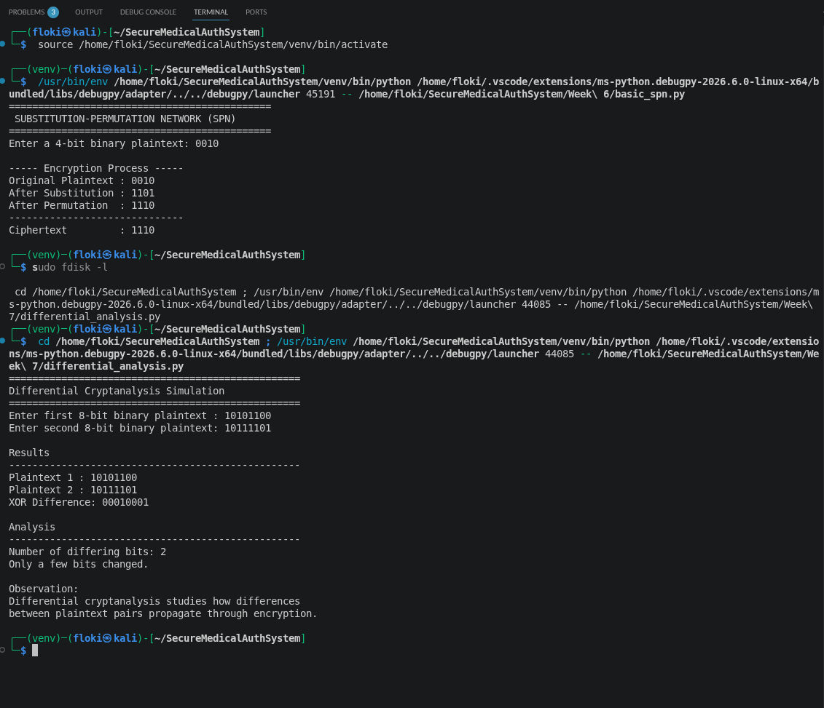
Fig 5

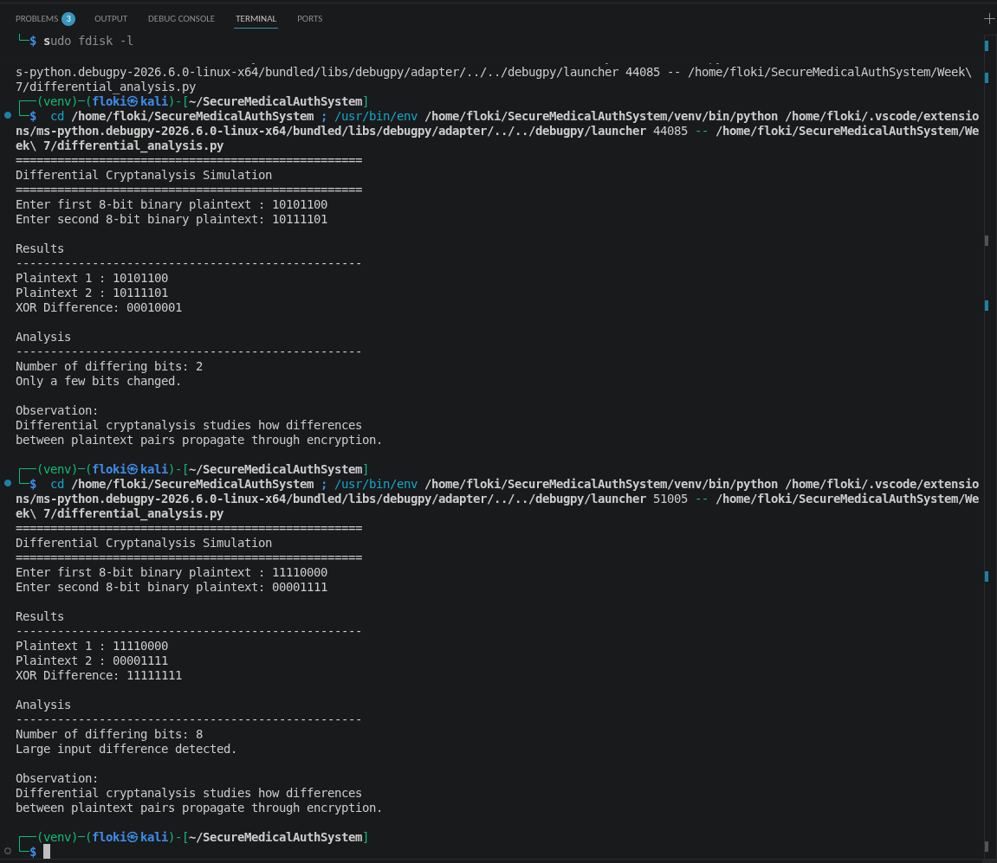
Fig. 6: Demonstration of maximum input difference between two plaintexts.

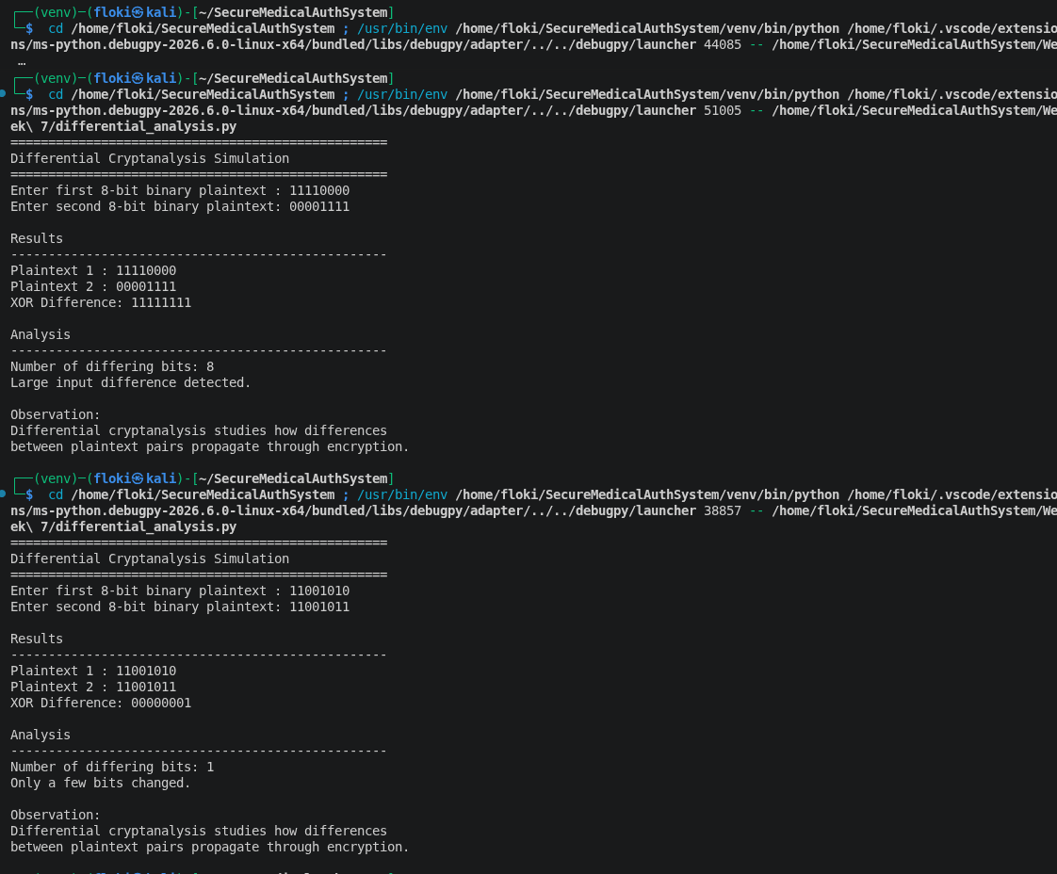
Fig. 7: Example showing a single-bit difference between two plaintext inputs.

Practical Task 2

Block Cipher Security Research
Objective
To study the major cryptanalytic techniques used to evaluate the security of block ciphers and understand why modern algorithms such as AES remain resistant to these attacks.

1. Differential Cryptanalysis
Differential cryptanalysis is a chosen-plaintext attack that examines how differences between pairs of plaintexts affect the differences in the resulting ciphertexts. By analyzing these patterns over many encryptions, an attacker attempts to recover information about the secret key.
How it works
- Two plaintexts with a known difference are selected.
- Both are encrypted using the same key.
- The resulting ciphertexts are compared.
- Statistical analysis is used to identify likely key values.
Advantages
- Effective against poorly designed block ciphers.
- Can expose weaknesses in S-Boxes and round functions.
Limitations
- Requires a large number of chosen plaintexts.
- Strong ciphers such as AES are designed to resist this attack through carefully designed S-Boxes and diffusion layers.

2. Linear Cryptanalysis
Linear cryptanalysis is a known-plaintext attack that attempts to find linear relationships between plaintext bits, ciphertext bits, and key bits.
How it works
- Collect many plaintext-ciphertext pairs.
- Identify approximate linear equations.
- Use statistical analysis to determine probable key bits.
Advantages
- Can reduce the effort required for brute-force attacks.
- Useful for evaluating cipher security.
Limitations
- Requires a very large dataset.
- Modern block ciphers minimize exploitable linear relationships.

3. Algebraic Attacks
Algebraic attacks represent the encryption algorithm as a system of mathematical equations. The attacker attempts to solve these equations to recover the encryption key.
How it works
- Express encryption operations as Boolean equations.
- Use algebraic methods to solve for unknown key bits.
Advantages
- Can be effective against algorithms with simple algebraic structures.
Limitations
- Computationally expensive.
- Strong non-linearity and complex key schedules make modern ciphers resistant.

Comparison of Cryptanalysis Techniques
Attack | Required Data | Main Idea | Effectiveness
Differential Cryptanalysis | Chosen plaintexts | Studies input/output differences | Effective against weak designs
Linear Cryptanalysis | Known plaintexts | Finds approximate linear relationships | Effective against weak linear structures
Algebraic Attacks | Cipher equations | Solves mathematical equations | Effective only when algebraic complexity is low

Why AES Resists These Attacks
AES incorporates several design features that provide strong resistance:
- Highly non-linear S-Boxes.
- Multiple rounds of substitution and permutation.
- Strong diffusion through the MixColumns transformation.
- Complex key expansion process.
- Excellent avalanche effect, where changing one input bit affects many output bits.
Conclusion
Differential, linear, and algebraic cryptanalysis are essential tools for evaluating the security of block ciphers. While they can reveal weaknesses in poorly designed algorithms, modern ciphers such as AES have been specifically engineered to withstand these attacks through strong non-linearity, diffusion, and robust key scheduling.
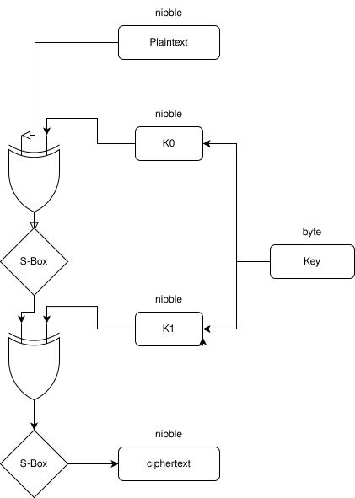
Fig 8: Conceptual representation of an algebraic attack using mathematical equations.

Practical Task 3

Security Evaluation of AES
Objective
To evaluate the security of the Advanced Encryption Standard (AES) and explain why it is widely trusted for protecting sensitive information.
Overview of AES
The Advanced Encryption Standard (AES) is a symmetric-key block cipher adopted by the U.S. National Institute of Standards and Technology (NIST) in 2001. It encrypts data in 128-bit blocks and supports key sizes of 128, 192, and 256 bits.

Security Features of AES
1. Strong Non-Linearity
AES uses a carefully designed S-Box that introduces non-linear transformations, making it extremely difficult for attackers to predict relationships between plaintext and ciphertext.
2. Confusion and Diffusion
AES combines:
- SubBytes (confusion)
- ShiftRows (diffusion)
- MixColumns (diffusion)
- AddRoundKey (key mixing)
Together, these operations provide excellent resistance to cryptanalysis.
3. Avalanche Effect
Changing a single bit in either the plaintext or the encryption key causes many bits in the ciphertext to change, making patterns extremely difficult to detect.
4. Resistance to Modern Attacks
AES is resistant to:
- Differential cryptanalysis
- Linear cryptanalysis
- Algebraic attacks
- Brute-force attacks (when appropriate key sizes are used)

Advantages of AES
- Fast and efficient.
- Strong security.
- Widely supported in hardware and software.
- Trusted by governments, banks, healthcare systems, and cloud providers.
- International encryption standard.
Limitations
- Side-channel attacks remain possible if implementations are not secure.
- AES-128 offers a smaller security margin than AES-256, though it remains secure for most applications.

Overall Evaluation
Criterion | Evaluation
Confidentiality | Excellent
Performance | Excellent
Resistance to Differential Cryptanalysis | Excellent
Resistance to Linear Cryptanalysis | Excellent
Resistance to Algebraic Attacks | Very High
Industry Adoption | Excellent

Conclusion
AES remains one of the most secure and widely used encryption algorithms available today. Its combination of non-linear substitution, strong diffusion, multiple encryption rounds, and robust key scheduling makes it highly resistant to modern cryptanalytic attacks. As a result, AES continues to be the preferred standard for securing sensitive information across industries worldwide.

Figures for Practical Task 3
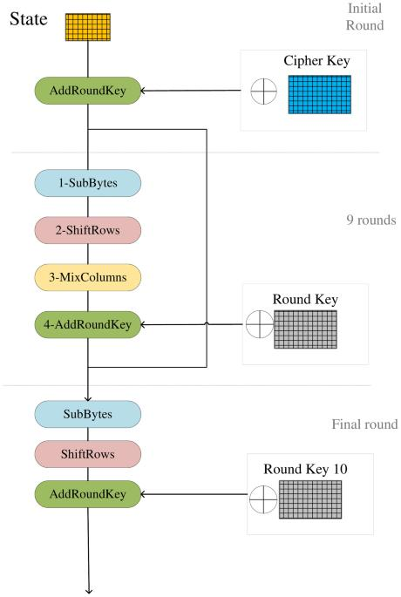
Fig. 9: The sequence of operations in an AES encryption round.
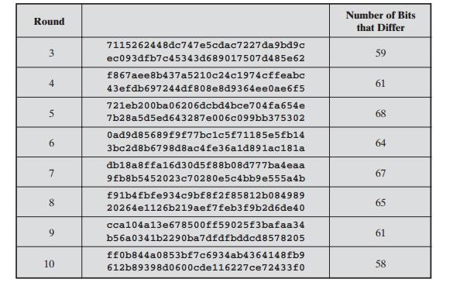

Fig. 10: Avalanche effect in AES, demonstrating how a one-bit change in input produces a significantly different ciphertext.
.

Week 8

Activity 1: PKI Component Identification
Question: Identify the role played by each of the following:
a) Certificate Authority (CA)
A Certificate Authority (CA) is a trusted organization responsible for issuing, managing, renewing, and revoking digital certificates. Before issuing a certificate, the CA verifies the identity of the certificate applicant. The CA's digital signature assures users that the certificate is authentic and can be trusted.
Examples: DigiCert, Sectigo, GlobalSign.

b) Registration Authority (RA)
A Registration Authority (RA) acts as an intermediary between users and the Certificate Authority. It verifies the identity of users requesting certificates and forwards approved requests to the CA for certificate issuance.
Its main responsibilities include:
- Identity verification
- Processing certificate requests
- Communicating with the Certificate Authority

c) Digital Certificate
A digital certificate is an electronic document that links a user's identity with their public key. It is digitally signed by a trusted Certificate Authority and is used to verify that a public key belongs to its claimed owner.
A certificate typically contains:
- Owner's name
- Public key
- Certificate serial number
- Issuing CA
- Validity period
- Digital signature of the CA
d) End User
An End User is the individual, organization, or system that uses digital certificates for secure communication.
Examples include:
- Website owners
- Banks
- Government agencies
- Email users
- VPN users
End users rely on certificates for authentication, encryption, and digital signatures.

e) Certificate Repository
A Certificate Repository is a secure database where issued certificates and Certificate Revocation Lists (CRLs) are stored.
Its functions include:
- Storing issued certificates
- Allowing certificate retrieval
- Publishing revoked certificates
- Supporting certificate validation

Activity 2: Certificate Analysis
Website Selected: https://www.google.com
Certificate Analysis Report
Item | Details
Website | https://www.google.com
Subject Name | CN=www.google.com
Issuing Certificate Authority | Google Trust Services LLC
Public Key Algorithm | RSA 2048-bit
Signature Algorithm | SHA-256 with RSA Encryption
Certificate Purpose | Server Authentication
Validity | Approximately 90 days (Google regularly rotates certificates)
Findings
The Google website uses an X.509 digital certificate issued by Google Trust Services LLC. The certificate authenticates the website's identity before encrypted communication begins. The certificate uses RSA public-key cryptography together with SHA-256 for digital signatures. During the TLS handshake, browsers verify the certificate's authenticity before establishing a secure encrypted session.
Conclusion
The certificate demonstrates how PKI enables secure communication by ensuring authentication, confidentiality, integrity, and trust between users and websites.

Activity 3: Practical Task – OpenSSL Certificate Inspection
Objective
Inspect a website's SSL certificate using OpenSSL.

Step 1: Download the Certificate
Run:

openssl s_client -connect google.com:443 -showcerts </dev/null \
| openssl x509 > certificate.pem

This downloads Google's server certificate.

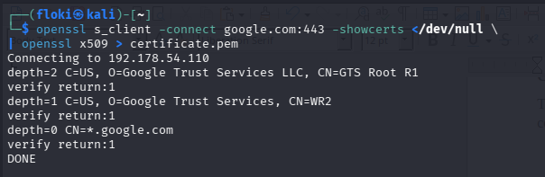
Fig 1: Downloaded Google’s server certificate

Step 2: Inspect the Certificate
Run:

openssl x509 -in certificate.pem -text -noout

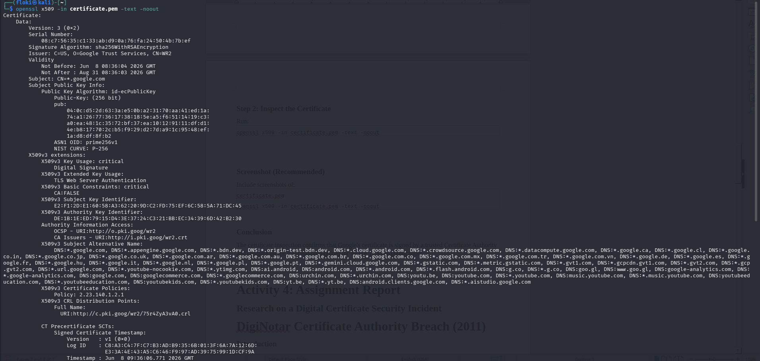
Fig 2: Inspection of the certificate’s

Conclusion
The certificate inspection confirms that Google's certificate is signed by a trusted Certificate Authority and contains all the information required for secure TLS communication.

Activity 4: Assignment Report

Research on a Digital Certificate Security Incident

DigiNotar Certificate Authority Breach (2011)
Introduction
One of the most significant Certificate Authority security incidents occurred in 2011 when DigiNotar, a Dutch Certificate Authority, suffered a major cyberattack. The attackers successfully issued hundreds of fraudulent digital certificates, compromising trust in secure Internet communications.

1. Organization Involved
Organization: DigiNotar
DigiNotar was a Certificate Authority responsible for issuing SSL/TLS certificates used by websites and government organizations.

2. Cause of the Incident
The attackers exploited weak security controls within DigiNotar's internal systems.
The investigation revealed:
- Poor server security
- Outdated software
- Weak password policies
- Inadequate monitoring
- Lack of timely security updates
These weaknesses allowed attackers to gain administrative access and generate fake certificates.

3. Impact on Users
The attack had severe consequences.
Fraudulent certificates were issued for major websites, including:
- Google
- Yahoo
- Mozilla
- Microsoft
Users could unknowingly connect to fake websites without browser warnings.
The incident enabled potential:
- Man-in-the-Middle attacks
- Credential theft
- Email interception
- Privacy violations
Major browsers quickly revoked trust in DigiNotar certificates.

4. Corrective Actions
Following the breach:
- DigiNotar's certificates were revoked.
- Browser vendors removed DigiNotar from trusted CA lists.
- Governments replaced affected certificates.
- Security audits became stricter.
- Certificate transparency initiatives were introduced.
Eventually, DigiNotar declared bankruptcy.

5. Lessons Learned
The DigiNotar breach demonstrated that trust in PKI depends on the security of Certificate Authorities.
Important lessons include:
- Regular security audits are essential.
- Strong access controls must be enforced.
- Continuous monitoring detects attacks early.
- Certificate Transparency improves accountability.
- Rapid certificate revocation minimizes damage.

Conclusion
The DigiNotar incident remains one of the most important lessons in PKI security. It highlighted the importance of protecting Certificate Authorities because compromising a CA can undermine trust across the entire Internet.

Activity 5: Class Exercise 1

Understanding Asymmetric Cryptography
a) Public Key
A public key is a cryptographic key that can be shared openly with anyone. It is primarily used for encrypting data and verifying digital signatures. Since it is publicly available, anyone can use it to send encrypted messages to the key owner.

b) Private Key
A private key is a secret cryptographic key known only to its owner. It is used to decrypt messages encrypted with the corresponding public key and to create digital signatures. Protecting the private key is critical because anyone who obtains it can impersonate the owner.

c) Symmetric Encryption
Symmetric encryption uses a single secret key for both encryption and decryption. Both the sender and receiver must possess the same key before communication begins. It is much faster than asymmetric encryption and is commonly used for encrypting large amounts of data.
Examples: AES, DES, 3DES.

d) Asymmetric Encryption
Asymmetric encryption uses a pair of mathematically related keys: a public key and a private key. The public key encrypts data, while the private key decrypts it. It also enables digital signatures and secure key exchange without requiring a shared secret beforehand.
Examples: RSA, Diffie-Hellman, and ECC.

Activity 6: Class Exercise 2

Complexity and Cryptography
Question
Discuss why computationally hard problems are important in modern cryptographic systems. Provide at least three examples.

Answer
Computationally hard problems form the foundation of modern cryptography because they make encrypted information practically impossible to break using current computing technology. A cryptographic algorithm is considered secure when encryption is easy for legitimate users but extremely difficult for attackers to reverse without the appropriate key. The enormous amount of time and computational resources required to solve these problems protects sensitive information from unauthorized access.

Hard mathematical problems ensure that even if an attacker knows the encryption algorithm, recovering the secret key within a reasonable time remains infeasible. This concept is known as computational intractability, where solving certain mathematical problems becomes increasingly difficult as the problem size grows.
Examples of Computationally Hard Problems
1. Integer Factorization Problem
The Integer Factorization Problem involves decomposing a very large composite number into its prime factors. While multiplying two prime numbers is easy, finding the original primes from their product is computationally difficult.

Application: RSA encryption relies on the difficulty of factoring large integers.
2. Discrete Logarithm Problem
The Discrete Logarithm Problem involves determining the exponent in an equation of the form:
g
x
modp

Although computing modular exponentiation is efficient, determining the value of x from the result is extremely difficult.

Application: Diffie-Hellman Key Exchange and ElGamal encryption.

3. Elliptic Curve Discrete Logarithm Problem (ECDLP)
The Elliptic Curve Discrete Logarithm Problem requires finding a secret scalar used to generate a point on an elliptic curve.
This problem is even more difficult than the traditional discrete logarithm problem for equivalent key sizes.

Application: Elliptic Curve Cryptography (ECC).
Importance in Cryptography
- Computationally hard problems provide several important security benefits:
- Protect encrypted information from brute-force attacks.
- Enable secure key exchange over insecure networks.
- Support digital signatures for authentication.
- Maintain confidentiality and integrity of sensitive information.
- Provide long-term security for Internet communications.
Conclusion
Without computationally difficult mathematical problems, modern cryptographic systems such as RSA, Diffie-Hellman, and ECC would be vulnerable to attack. Their security depends on the practical impossibility of solving these problems within a reasonable amount of time.

Activity 7: Practical Task

Implementing Diffie-Hellman Key Exchange in Python
Objective
Develop a Python program that:
Accepts public values p and g
Allows two users to choose private keys
Generates public keys
Computes the shared secret
Verifies that both users obtain the same secret key

Python Program
# Diffie-Hellman Key Exchange Implementation

print("===== Diffie-Hellman Key Exchange =====")

# Public values
p = int(input("Enter Public Prime (p): "))
g = int(input("Enter Generator (g): "))

# Private keys
alice_private = int(input("Enter Alice's Private Key: "))
bob_private = int(input("Enter Bob's Private Key: "))

# Generate public keys
alice_public = pow(g, alice_private, p)
bob_public = pow(g, bob_private, p)

# Compute shared secret
alice_secret = pow(bob_public, alice_private, p)
bob_secret = pow(alice_public, bob_private, p)

print("\n----- Results -----")
print("Alice Public Key :", alice_public)
print("Bob Public Key :", bob_public)
print("Alice Secret :", alice_secret)
print("Bob Secret :", bob_secret)

if alice_secret == bob_secret:
print("\nKey Exchange Successful!")
print("Shared Secret =", alice_secret)
else:
print("\nKey Exchange Failed.")

Sample Execution
===== Diffie-Hellman Key Exchange =====

Enter Public Prime (p): 23
Enter Generator (g): 5
Enter Alice's Private Key: 6
Enter Bob's Private Key: 15

----- Results -----
Alice Public Key : 8
Bob Public Key : 19
Alice Secret : 2
Bob Secret : 2

Key Exchange Successful!
Shared Secret = 2

Explanation
The program begins by accepting the public parameters p (a prime number) and g (a generator), which are known to both communicating parties. Alice and Bob then independently choose their private keys, which remain secret. Each user computes a corresponding public key using modular exponentiation and exchanges it over the insecure communication channel.

After exchanging public keys, Alice and Bob each compute the shared secret using their own private key and the other party's public key. Because of the mathematical properties of the Diffie-Hellman algorithm, both users obtain the same shared secret without ever transmitting it across the network. The program finally verifies that the two computed secrets match, confirming a successful key exchange.

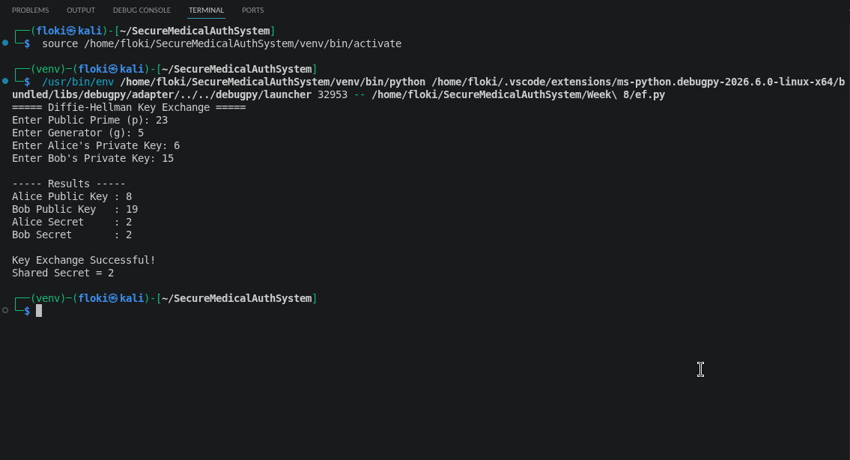
Fig 3: Implementing Diffie-Hellman Key Exchange in Python

Activity 8: Assignment

The Role of Diffie-Hellman Key Exchange in Modern Internet Security
Introduction
The rapid growth of the Internet has increased the need for secure communication between users and online services. One of the most significant challenges in network security is enabling two parties to establish a shared secret over an insecure communication channel without previously sharing any confidential information. The Diffie-Hellman Key Exchange protocol addresses this challenge by allowing secure generation of a shared secret key that can later be used for encryption. Since its introduction in 1976 by Whitfield Diffie and Martin Hellman, the protocol has become one of the cornerstones of modern cryptography.

1. Definition of Diffie-Hellman
Diffie-Hellman Key Exchange is a public-key cryptographic protocol that enables two communicating parties to establish a common secret key over an unsecured network. Unlike traditional encryption methods, Diffie-Hellman is not designed to encrypt data directly. Instead, it securely generates a shared secret that can subsequently be used with symmetric encryption algorithms such as AES for confidential communication.

2. How the Protocol Works
The protocol begins with two publicly known values: a large prime number (p) and a generator (g). These values are available to everyone, including potential attackers.

Each participant independently selects a private key. Alice chooses a secret integer a, while Bob chooses another secret integer b. Using these private values, they compute their respective public keys through modular exponentiation and exchange the public keys over the network.
Alice combines Bob's public key with her own private key to compute a shared secret, while Bob performs the same computation using Alice's public key and his own private key. Both users independently arrive at the same shared secret without ever transmitting it. An attacker observing the exchanged public information cannot feasibly derive the secret because of the computational difficulty of the underlying mathematical problem.

3. The Discrete Logarithm Problem
The security of Diffie-Hellman depends on the Discrete Logarithm Problem (DLP). Given a large prime number, a generator, and the result of modular exponentiation, determining the original exponent is computationally infeasible using current algorithms and computing power.

This mathematical difficulty prevents attackers from recovering private keys even if they intercept all public communications. The larger the prime number used, the more secure the protocol becomes against brute-force attacks.

4. Applications in TLS/SSL
Diffie-Hellman is extensively used in Transport Layer Security (TLS), the protocol responsible for securing HTTPS websites. During the TLS handshake, the client and server use Diffie-Hellman or its elliptic curve variant (ECDHE) to generate a temporary shared secret. This secret is then used to derive symmetric encryption keys for the remainder of the session.

Modern web browsers, online banking platforms, cloud services, virtual private networks (VPNs), and secure messaging applications all rely on Diffie-Hellman-based key exchange mechanisms. The protocol also provides Perfect Forward Secrecy (PFS) when ephemeral keys are used, ensuring that past communications remain secure even if long-term private keys are later compromised.

5. Security Challenges and Possible Solutions

Although Diffie-Hellman provides secure key exchange, it does not inherently authenticate the communicating parties. As a result, it is vulnerable to Man-in-the-Middle (MITM) attacks if authentication mechanisms are absent. In such attacks, an adversary intercepts communications and establishes separate shared secrets with each party while pretending to be the legitimate participant.

To mitigate these risks, Diffie-Hellman is commonly combined with digital certificates, Public Key Infrastructure (PKI), and digital signatures to verify identities before key exchange. Additionally, using sufficiently large prime numbers or Elliptic Curve Diffie-Hellman (ECDHE) significantly improves resistance to modern cryptographic attacks and enhances performance.

Conclusion
Diffie-Hellman remains one of the most influential developments in modern cryptography. By enabling secure key establishment over insecure networks, it supports the confidentiality and integrity of countless online services. Combined with authentication mechanisms and strong cryptographic parameters, the protocol continues to play a critical role in securing Internet communications, including web browsing, online banking, cloud computing, VPNs, and secure messaging applications. Its mathematical foundation and widespread adoption ensure that it remains an essential component of contemporary cybersecurity.

References
Stallings, W. (2017). Cryptography and Network Security: Principles and Practice (7th ed.). Pearson.
Katz, J., & Lindell, Y. (2020). Introduction to Modern Cryptography (3rd ed.). CRC Press.
Menezes, A., Van Oorschot, P., & Vanstone, S. (2018). Handbook of Applied Cryptography. CRC Press.
Diffie, W., & Hellman, M. E. (1976). New Directions in Cryptography. IEEE Transactions on Information Theory, 22(6), 644–654.

